Assignment:-1

**Program to Check Whether a Given Number is Even or Odd**

import java.util.Scanner;

class EvenOdd{

public static void main(String[] args) {

Scanner sc=new Scanner(System.in);

System.out.println("Enter the num");

int num =sc.nextInt();

if(num%2==0)

{

System.out.println("number is even");

}

else

{

System.out.println("number is odd");

}

}

}

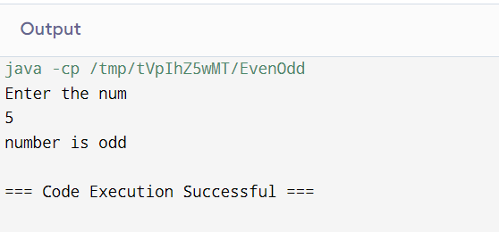

**Program to Print Odd Numbers in a Given Range**

import java.util.Scanner;

class Odd{

public static void main(String[] args) {

int arr[]={1,4,3,5,6};

System.out.println("odd numbers are:");

for(int i=0;i<arr.length;i++){

if(arr[i]%2!=0)

{

System.out.println(arr[i]+"");

}

}

}

}

**Program to Check Whether a Number is Positive or Not**

import java.util.Scanner;

class PositiveOrNot{

public static void main(String[] args) {

Scanner sc=new Scanner(System.in);

System.out.println("Enter the num");

int num =sc.nextInt();

if(num>0)

{

System.out.println("number is positive");

}

else{

System.out.println("number is negative");

}

}

}

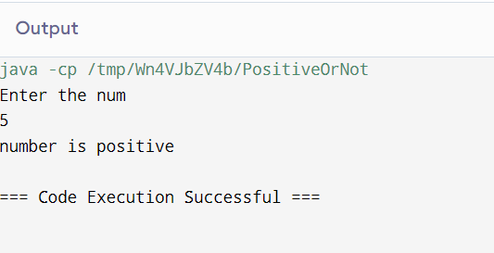

**Program to Find the Largest of Two Numbers**

import java.util.Scanner;

class GreterNumber{

public static void main(String[] args) {

Scanner sc=new Scanner(System.in);

System.out.println("Enter the two num");

int num1 =sc.nextInt();

int num2 =sc.nextInt();

if(num1>num2)

{

System.out.println("num1 is greter");

}

else{

System.out.println("num2 is greter");

}

}

}

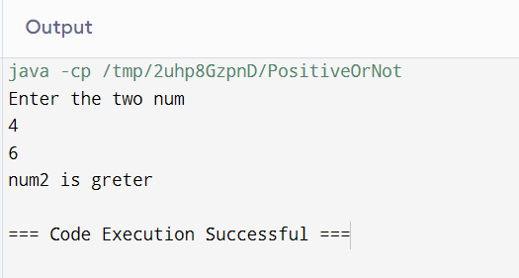

**Program to Swap Two Numbers**

import java.util.Scanner;

class GreterNumber{

public static void main(String[] args) {

int x,y,z;

Scanner sc=new Scanner(System.in);

System.out.println("Enter the two num");

x =sc.nextInt();

y =sc.nextInt();

System.out.println("after swapping");

z=x;

x=y;

y=z;

System.out.println("x="+x+",y="+y);

}

}  
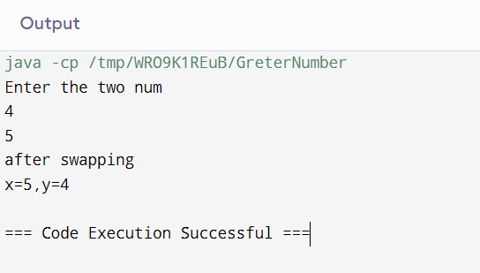

**Program to Check if a Number is Divisible by 2**

import java.util.Scanner;

class DivisibleByTwo{

public static void main(String[] args) {

Scanner sc=new Scanner(System.in);

System.out.println("Enter the num");

int num =sc.nextInt();

if(num%2==0)

{

System.out.println("The number is divisible by 2");

}

else{

System.out.println("The number is not divisible by 2");

}

}

}

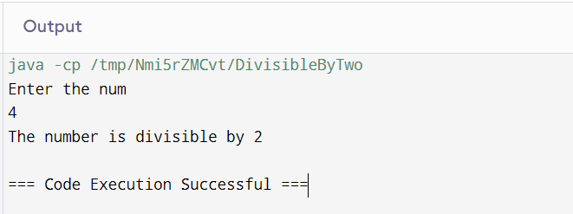

**Program to Find the Sum of All the Multiples of 3 and 5**

import java.util.Scanner;

class Sum{

public static void main(String[] args) {

int i,arr[]={1,12,15,30,7,8,6,60};

int sum=0;

for(i=0;i<arr.length;i++){

if(arr[i]%3==0 && arr[i]%5==0)

{

sum+=arr[i];

}

}

System.out.println("sum of number which is divisible by 3 and 5="+sum);

}

}

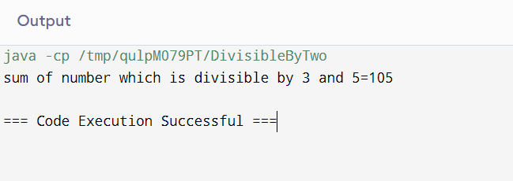

**Program to Find Sum of Digits of a Number**

import java.util.Scanner;

class SumOfDigit{

public static void main(String[] args) {

Scanner sc=new Scanner(System.in);

System.out.println("Enter the num");

int num =sc.nextInt();

int sum=0,digit;

while(num!=0){

digit=num % 10;

sum +=digit;

num=num/10;

}

System.out.println("sum ="+sum);

}

}

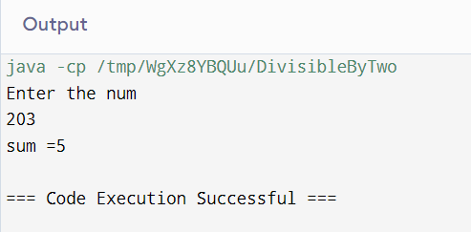

**Program to Reverse a Number**

import java.util.Scanner;

class SumOfDigit{

public static void main(String[] args) {

Scanner sc=new Scanner(System.in);

System.out.println("Enter the num");

int num =sc.nextInt();

int sum=0,digit;

while(num!=0){

digit=num % 10;

System.out.print(+digit);

num=num/10;

}

}

}

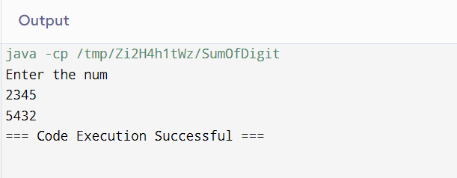

**Program to Reverse a Number and Check if it is a Palindrome**

import java.util.Scanner;

class Polindrom{

public static void main(String[] args) {

Scanner sc=new Scanner(System.in);

System.out.println("Enter the num");

int num =sc.nextInt();

int sum=0,digit;

int n=num;

int rev=0;

while(num!=0){

digit=num % 10;

rev=rev*10+digit;

num=num/10;

}

if(n==rev)

{

System.out.println("the number is polindrom");

}

}

}

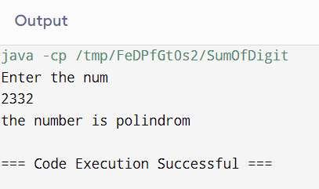

**Program to Calculate the Sum, Multiplication, Division and Subtraction of Two Numbers(use switch case)**

import java.util.Scanner;

class Polindrom{

public static void main(String[] args) {

Scanner sc=new Scanner(System.in);

System.out.println("Enter the num1");

int num1 =sc.nextInt();

System.out.println("Enter the num2");

int num2 =sc.nextInt();

System.out.println("1.ADD,2.SUB,3.MUL,4.DIV");

int result;

int c=sc.nextInt();

switch(c)

{

case 1:

System.out.println("ADD");

result=num1+num2;

System.out.println(+result);

break;

case 2:

System.out.println("SUB");

result=num1-num2;

System.out.println(+result);

Break;

case 3:

System.out.println("MUL");

result=num1*num2;

System.out.println(+result);

break;

case 4:

System.out.println("Div");

result=num1/num2;

System.out.println(+result);

break;

}

}

}

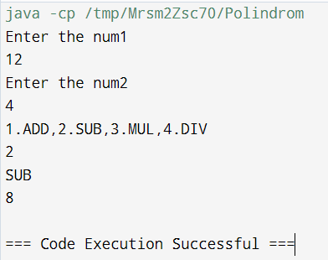

**Program to Generate Fibonacci Series**

import java.util.Scanner;

class Polindrom{

public static void main(String[] args) {

int n1=0,n2=1,n3,i,count=10;

for(i=2;i<count;i++)

{

n3=n2+n1;

System.out.println(+n3);

n1=n2;

n2=n3;

}

}

}

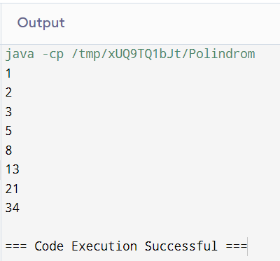

**Program to Print the Factorial of a Given Number**

import java.util.Scanner;

class Polindrom{

public static void main(String[] args) {

int i,fact=1;

Scanner sc=new Scanner(System.in);

System.out.println("Enter the number");

int num=sc.nextInt();

for(i=1;i<5;i++)

{

fact=fact*i;

}

System.out.println("factorial of the given number"+fact);

}

}

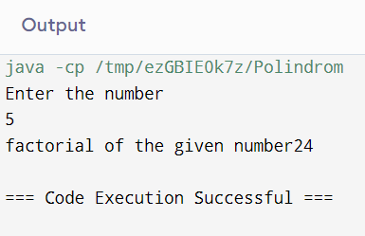

**Program to Find the Sum of First 50 Natural Numbers using For Loop**

import java.util.Scanner;

class Polindrom{

public static void main(String[] args) {

int sum=0,i;

for(i=1;i<50;i++)

{

sum+=i;

}

System.out.println("sum of the natural number="+sum);

}

}

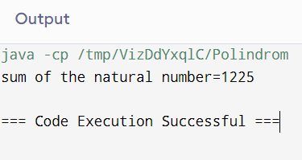

**Program to Generate the Sum of N Numbers**

import java.util.Scanner;

class Polindrom{

public static void main(String[] args) {

int sum=0,i,n;

Scanner sc=new Scanner(System.in);

System.out.println("Enter the value of n ");

n=sc.nextInt();

for(i=1;i<=n;i++)

{

sum+=i;

}

System.out.println("sum of the natural number="+sum);

}

}

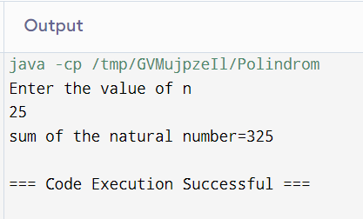

**Program to Find the Sum of Two Binary Numbers**

import java.util.Scanner;

class EvenOdd{

public static void main(String[] args)

{

long n1,n2;

int i=0,rem=0;

int[] sum=new int[20];

Scanner scanner=new Scanner(System.in);

System.out.println("Enter the first binary number: ");

n1=scanner.nextLong();

System.out.println("Enter the second binary number: ");

n2=scanner.nextLong();

while(n1!=0 || n2!=0)

{

sum[i++]=(int)((n1%10+n2%10+rem)%2);

rem=(int)((n1%10+n2%10+rem)/2);

n1=n1/10;

n2=n2/10;

}

if(rem!=0)

{

sum[i++]=rem;

}

--i;

System.out.println("sum of two binary numbers: ");

while(i>=0)

{

System.out.print(sum[i--]);

}

System.out.println("\n");

}

}

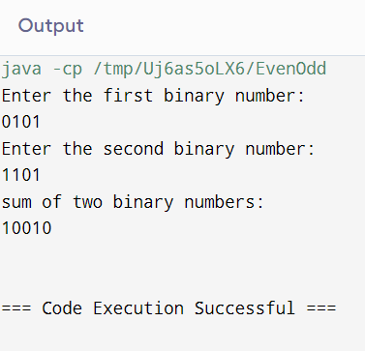

**Program to Multiply Two Binary Numbers**

import java.util.Scanner;

class EvenOdd{

public static void main(String[] args)

{

long n1,n2,mul=0;

int digit,factor=1;

Scanner scanner=new Scanner(System.in);

System.out.println("Enter the first binary number: ");

n1=scanner.nextLong();

System.out.println("Enter the second binary number: ");

n2=scanner.nextLong();

while(n2!=0)

{

digit=(int)(n2%10);

if(digit==1)

{

n1=n1*factor;

mul=binarypro((int) n1,(int)mul);

}else

{

n1=n1*factor;

}

n2=n2/10;

factor=10;

} System.out.println("Product of two binary numbers is: "+mul);

}

static int binarypro(int n1, int n2)

{

int i=0,rem=0;

int[] sum=new int[20];

int binaryproduct=0;

while(n1!=0 || n2!=0)

{

sum[i++]=(n1%10+n2%10+rem)%2;

rem=(n1%10+n2%10+rem)/2;

n1=n1/10;

n2=n2/10;

}

if(rem!=0)

{

sum[i++]=rem;

}

--i;

while(i>=0)

{

binaryproduct=binaryproduct*10+sum[i--];

}

return binaryproduct;

}

}

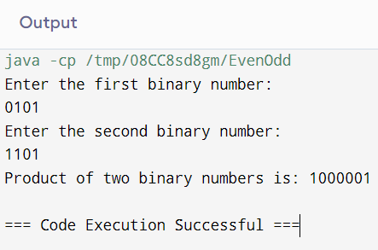

**Program to Print All the Prime Numbers between 1 to 100**

import java.util.*;

class NumberPrime {

public static void main(String[] args) {

Scanner sc = new Scanner(System.in);

System.out.println("Enter the Number:");

int no = sc.nextInt();

for(int i=2;i<=no;i++)

{

boolean isPrime = true;

for(int j=2;j<i;j++)

{

if(i%j==0)

{

isPrime = false;

break;

}

}

if(isPrime)

{

System.out.print(i + " ");

}

}

}

}

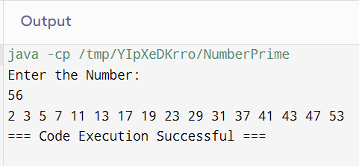

**Program to Check Whether a Given Number is Perfect Number**

import java.util.*;

class PerfectNumberCheck {

public static void main(String[] args) {

Scanner sc = new Scanner(System.in);

System.out.print("Enter the number: ");

int no = sc.nextInt();

int sum = 0;

for(int i=1;i<no;i++)

{

if(no%i==0)

{

sum += i;

}

}

if(sum == no)

{

System.out.println(no + " is a perfect number");

}

else

{

System.out.println(no + " is not a perfect number");

}

}

}

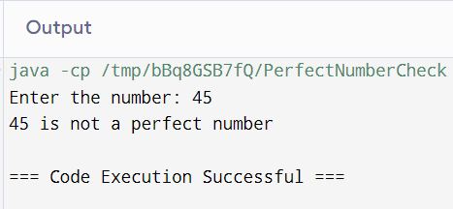

**Program to Check Armstrong Number**

import java.util.*;

class ArmstrongNumberCheck {

public static void main(String[] args) {

Scanner sc = new Scanner(System.in);

System.out.print("Enter the number: ");

int number = sc.nextInt();

int sum = 0;

int originalNumber = number;

int digits = 0;

while(number!=0)

{

number /= 10;

digits++;

}

number = originalNumber;

while(number!=0)

{

int remainder = number % 10;

sum += Math.pow(remainder, digits);

number /= 10;

}

if(sum == originalNumber)

{

System.out.println(originalNumber + " is an Armstrong Number");

}

else

{

System.out.println(originalNumber + " is not an Armstrong Number");

}

}

}

